**Name; Omar Matano**

**Adm No. BSCIT-01-0398/2019**

**Unit; Data Communication**

**CAT II**

1. Encapsulation - The term encapsulation describes a process of putting headers (and sometimes trailers) around some data.
2. TCP 3-way handshake

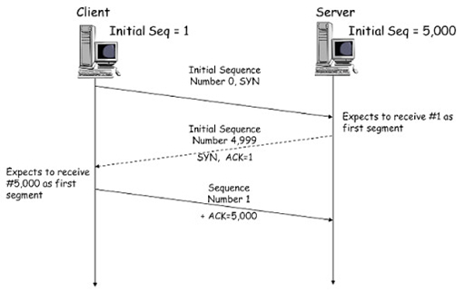

1. DHCP lease & rebinding process
2. Encapsulation in OSI network reference model

the term encapsulation describes the process of putting headers (and sometimes trailers) around some data. Like with the TCP/IP layers, each OSI layer asks for services from the next lower layer. The lower layer encapsulates the higher layer’s data between a header (Data Link protocols also add a trailer). While the TCP/IP model uses terms like segment, packet and frame to refer to a data packet defined by a particular layer, the OSI model uses a different term: protocol data unit (PDU).

A PDU represent a unit of data with headers and trailers for the particular layer, as well as the encapsulated data. Since the OSI model has 7 layers, PDUs are numbered from 1 to 7, with the Physical layer being the first one. For example, the term Layer 3 PDU refers to the data encapsulated at the Network layer of the OSI model.

Here is a graphical representation of the PDUs in the OSI model:

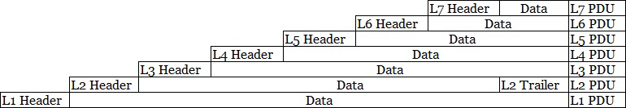

1. ICMP messages explanation
2. *Echo Request, Echo Reply*

Used to test destination accessibility and status. A host sends an Echo Request and listens for a corresponding Echo Reply. This is most commonly done using the ping command.

1. *Destination Unreachable, Echo Reply*

Sent by a router when it cannot deliver an IP datagram. A datagram is the unit of data, or packet, transmitted in a TCP/IP network.

1. Ethernet standard frame formats
2. Ethernet II

An Ethernet frame must be at least 64 bytes for collision detection to work, and can be a maximum of 1,518 bytes. The packet starts with a preamble that controls the synchronization between sender and receiver and a "Start Frame Delimiter" (SFD) that defines the frame. Both values are bit sequences in the format “10101010 ...” in which the actual frame contains information about source and destination addresses (MAC format), control information (in the case of Ethernet II the type field, later a length specification), followed by the transmitted data record. A frame check sequence (FCS) is an error-detecting code that closes the frame (except for the preamble and SFD). The packet is completed by an "InterFrame Gap," which defines a 9.6 μs transmission pause.

Ethernet II uses the classic frame structure with a type field ("Type") which defines various protocols of the network layer. In the OSI model, the network layer is important for connecting and providing network addresses. The type field was replaced by a length specification in later frame formats.

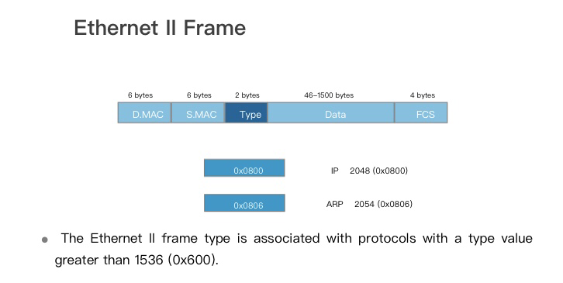

1. Ethernet IEEE 802.3

This standardized version of the Ethernet 802.3 frame can define up to 256 compatible protocols, with important protocol information integrated into the data field. In addition, the "Destination Service Access Point" (DSAP) and "Source Service Access Point" (SSAP) are included. The new control field defines the "Logical Link" (LLC) of the protocol. This point ensures the transparency of the media sharing procedures and can control the data flow.

Ethernet IEEE 802.3 is by far the most popular and widely used LAN frame structure today. However, some networks and protocols require more space for specific information. Consequently, there are variants of the IEEE 802.3 frame that provide additional data blocks for specific information, among them the SNAP extension and the VLAN tag.

